**Non Technical documentation**

Within in the folder CSE-702 there is a file named **checkers.apk**. This is an android game. To install it download it from an android device and install it. You can also install it from Google Play Store. This is the play store link.

[Click Here To Install](https://play.google.com/store/apps/details?id=com.ArtYourDreams.Checkers)

After installing you will find an application named Checkers in your android device. Now you open it and you will find an user interface like this,

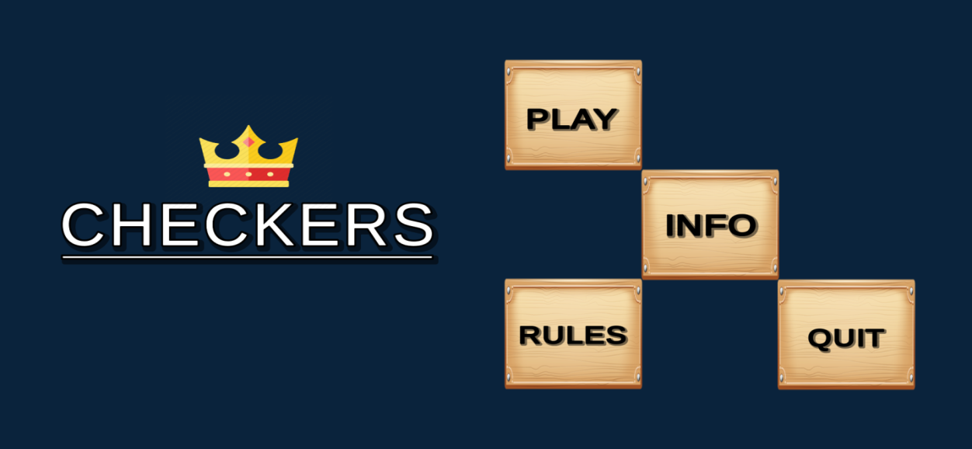

In the rules option you will find the “RULES” to play the game and in the “INFO” option you will find information about the developers, which means us.

Now in the “PLAY” option you will find an user interface like this,

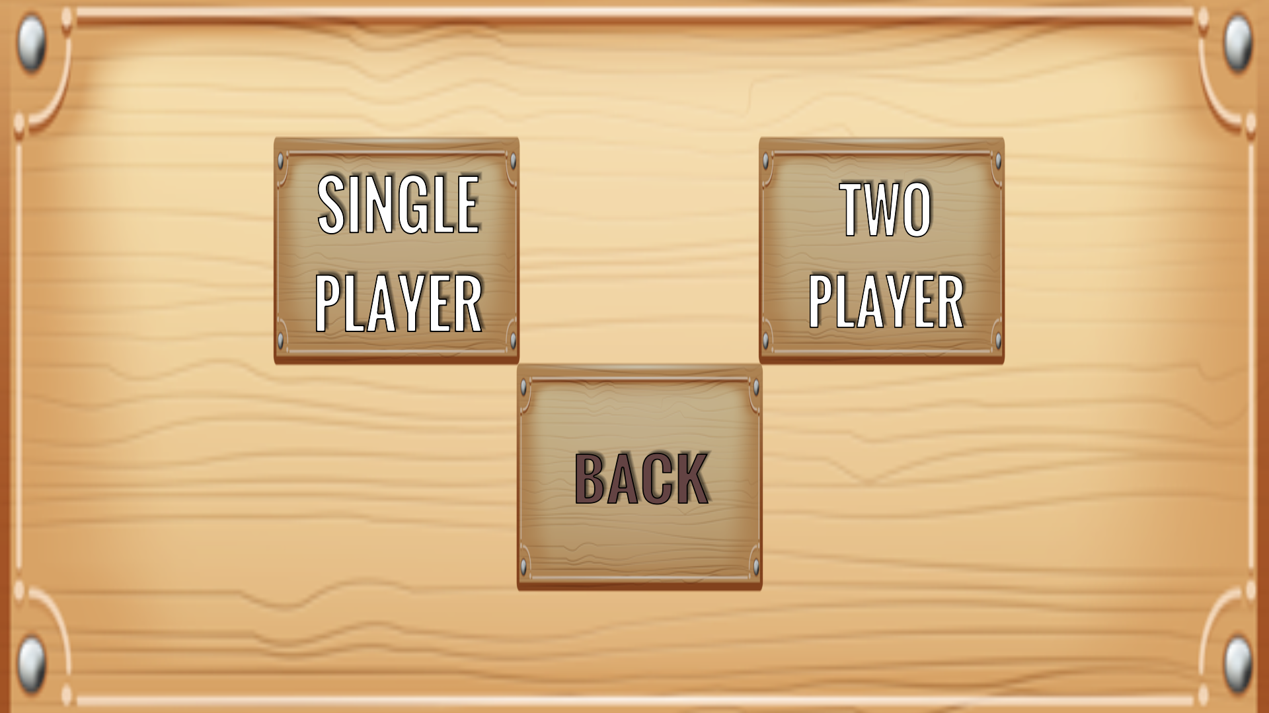

If you click on the “SINGLE PLAYER” button you will be able to play against the device(AI).If you choose “TWO PlAYER ” you will be able to play with your friend in local multiplayer.

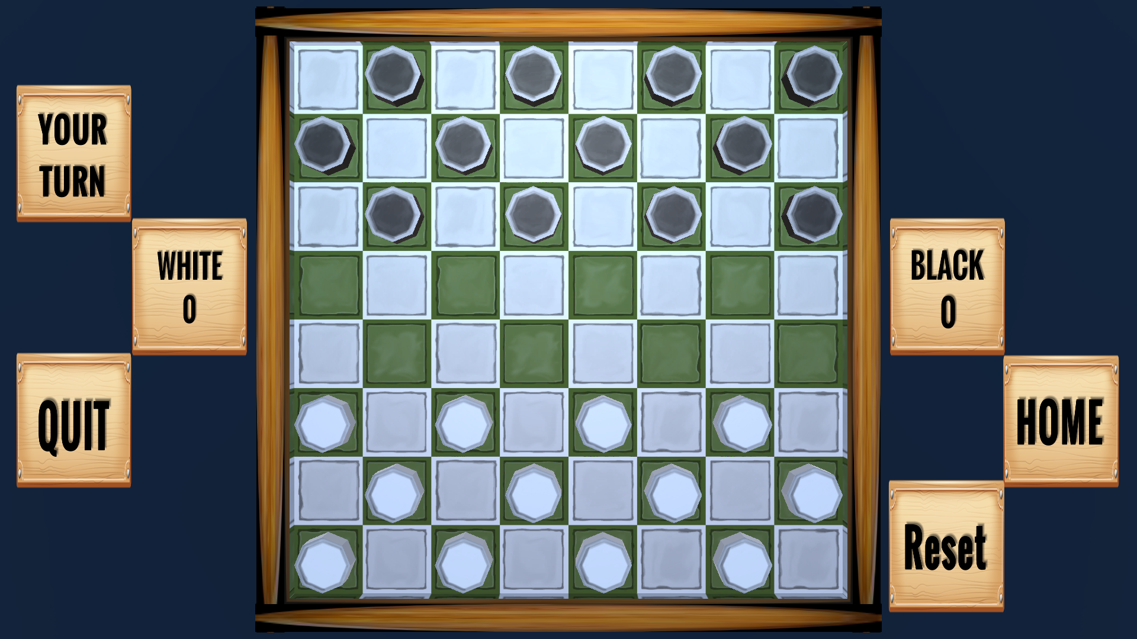

Press the targeted piece and drag to it’s new valid position and realease to move.